**AIM: 1.1 Familiarization with installation of any DBMS.**

**Description:**

# Introduction to Oracle 10g Express Edition and Installation

**a. Overview of Oracle 10g Express Edition:**

Oracle Database 10g Express Edition (Oracle Database XE) is a free, downloadable version of the world's most capable relational database. Oracle Database XE is easy to install and easy to manage.

# Interfaces

**Database Home Page**: Oracle XE included a web-based interface accessible through a browser, typically at [http://localhost:8080/apex.](http://localhost:8080/apex)

**SQL Command Line**: A simple command-line interface called "SQL Command Line" was included for direct SQL execution and basic administration tasks.

# b. Installation Steps

Click on the first file named OracleXE.exe to begin your downloading

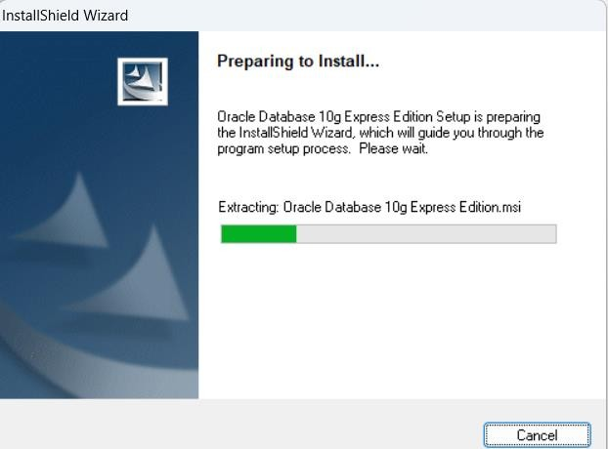

Click the Next button to begin to install the Oracle Database 10g Express Edition.

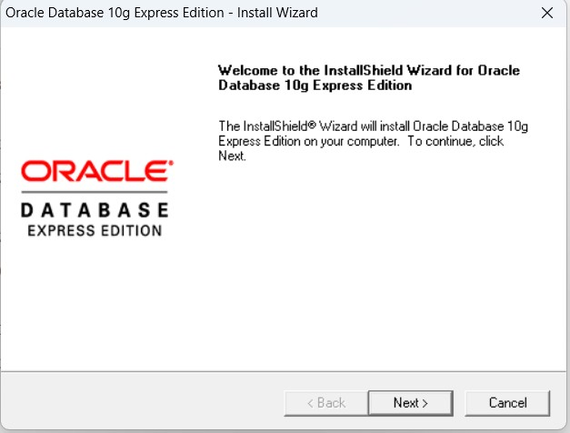

Select and click the Accept radio button followed by clicking the Next button to go to the next page.

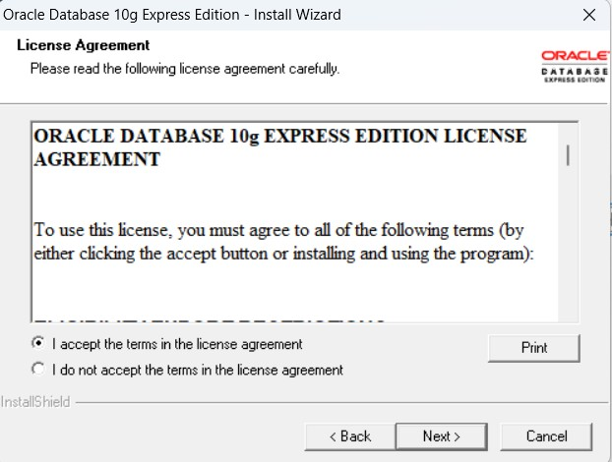

Select folder where setup will install files.

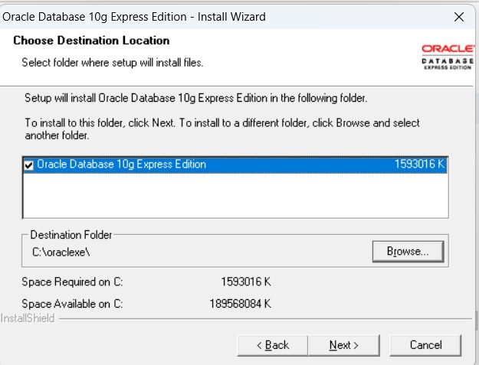

In the next dialog, you need to enter your password. You must remember this password since you need to use it to access your database installed in the Oracle server from your client computer later. The username is SYSTEM by default. This means that you need to use the SYSTEM as your username and the password you selected to open and access the database you created and installed in the Oracle server later.

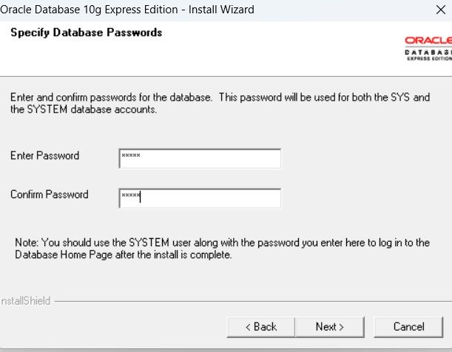

Click the Next button after you entered your desired password, and then click the Install button to begin this installation.

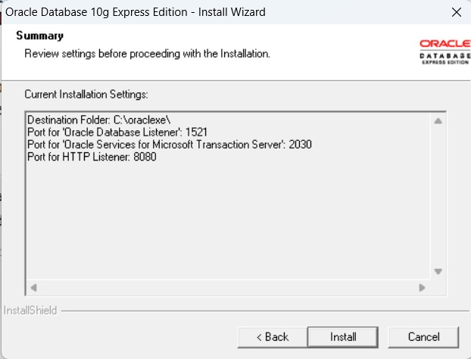

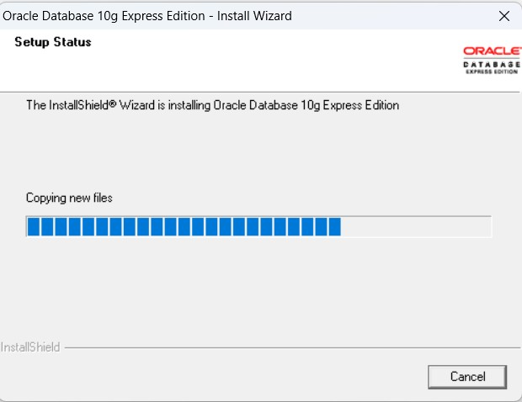

When this installation is complete, a finish dialog is displayed

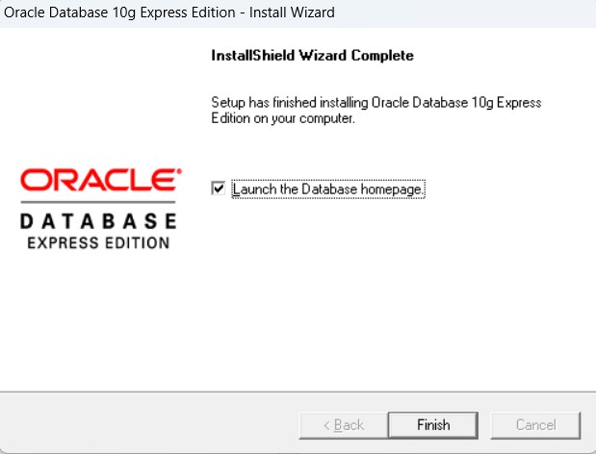

Click the Finish button to complete this installation.

The Database Login page is opened to allow you to enter your username and password to access the Oracle server to create, access and manipulate the database you created in this server.

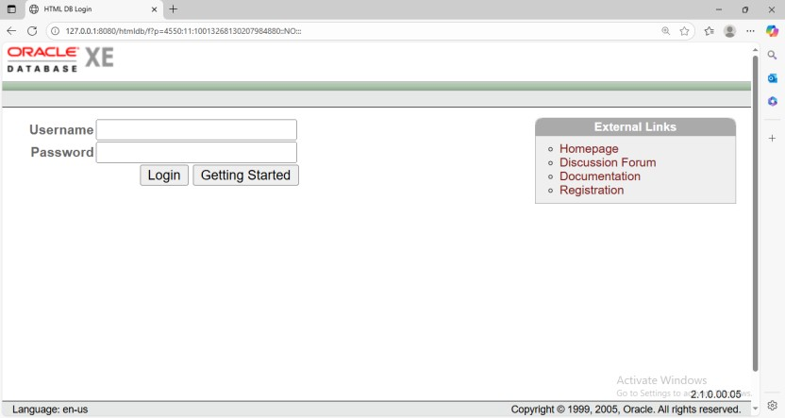

Enter the SYSTEM as your username and the password you selected when you installed the server, and then click the Login button to open the home page.

There are four icons on the opened home page

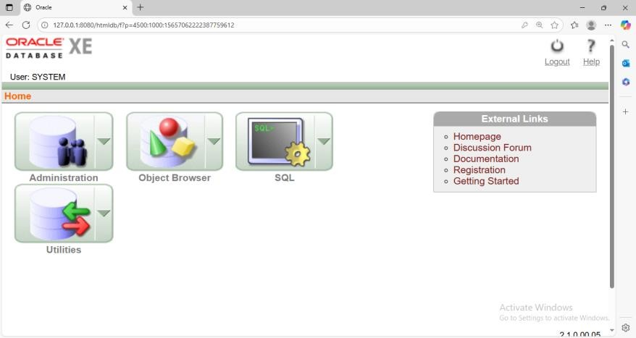

At this point, you have successfully finished the download and installation of the Oracle Database 10g Express Edition, which include the Oracle Database 10g Express server and the client. A Database Started Guide icon has been automatically added to your desktop on your computer. You can open this icon to follow the guide to access your database if you like. To connect your client to the server and start creating, accessing and manipulating your database, you need to open the Database home page by clicking the Start|All Program Files|Oracle Database 10g Express Edition|Go To Database Home Page. Then you can create and manipulate your database staring from the Object Browser icon.

**AIM: 1.2 Implementing a University Database System**.

**Description: a. Schema**

It is overall design of the database. It tells how many tables are there, what are their attributes, and how they are related. It includes table names, column names(attributes), datatypes, and keys.

**Syntax of Schema:**

Table Name (column1 : datatype, column2: datatype, column3: datatype, ……., columnN: datype) **b. Attributes per Table**

* **Students Table**

Attributes: StudentID, StudentName, Major

* **Courses Table**

Attributes: CourseID, CourseName, Credits

* **Enrollments Table**

Attributes: StudentID, CourseID, EnrollmentDate

* **Instructors Table**

Attributes: InstructorID, InstructorName, Phone

# • Course_Instructors Table

Attributes: CourseID, InstructorID

**c. Schema for University Database:**

Students (StudentID:string, StudentName:string, Major:string)

Courses (CourseID:string, CourseName:string, Credits:integer)

Enrollments (StudentID:string, CourseID:string, EnrollmentDate:date)

Instructors (InstructorID:integer, InstructorName:string, Phone:integer) Course_Instructors (CourseID:string, InstructorID:integer)

**AIM:2.1 Querying and modifying the database using Data Manipulation Language commands -select, insert, update, delete Description:**

DML COMMANDS are INSERT, UPDATE, DELETE and SELECT.

**INSERT COMMAND:**

This command is used to create data into the table which is already defined through DDL commands. The data can be entered in the form of rows and columns. **Syntax:** INSERT INTO <Table name>

(column1, [column2, ……….,columnN]) values (column1value,column2value,…..,columnNvalue); OR

INSERT INTO <Table name>

Values (column1value,column2value,…..,columnNvalue);

**UPDATE COMMAND:**

This command is used to modify or change or replace the existingdata of a table.

**Syntax:** UPDATE <Table_name>

Set <column1>=<column1value> [,<column2>=<column2value>,………

,<columnN>=<columnNvalue>]

[where<condition>];

**DELETE COMMAND:**

This command is used to remove a single row or multiple rows of a table.

**Syntax:** DELETE FROM<Table_name>

[where<condition>];

**SELECT COMMAND:**

This command is used to view a single row or multiple rows or single column or multiple columns of a table.

**Syntax:**

Select [distinct] column1,column2 as newname from table1,table2

Where condition

Group by columnname

Having condition

Order by columname asc|desc **Creating Students Table:**

create table students

(

rollno varchar2(30), name varchar2(30)

);

Table Created

**Inserting Data into the table** insert into students values('24B11CS234','Bala'); 1 row(s) inserted.

insert into students values('24B11CS381','Kiran'); 1 row(s) inserted.

# Displaying Data from the table select * from students;

|  |  |
| --- | --- |
| **ROLLNO** | **NAME** |
| 24B11CS234 | Bala |
| 24B11CS381 | Kiran |

select name from students;

|  |
| --- |
| **NAME** |
| Bala |
| Kiran |

select * from students9 where rollno='24B11CS234'

|  |  |
| --- | --- |
| **ROLLNO** | **NAME** |
| 24B11CS234 | Bala |

# Deleting a row from the table

delete from students where rollno='24B11CS381'; 1 row(s) deleted.

# Updating a row in the table

update students set name='Bala Raju' where rollno='24B11CS381'; 1 row(s) updated.

**AIM: 2.2 Implementation of Aggregate Functions – sum, avg, min, max, count. Use group-by and having clause. Description:**

# Aggregate Functions

**AVG function:** It can be used on numeric data or character data that contains only numeric’s.

**MAX function:** It is used to find the maximum value of x. It can be used on any type of data.

**MIN function:** It is used to find the minimum value of x

**SUM function:** It sums the values and can be used on numeric data also.

**COUNT(*):** It counts the number of rows in the table or the number of row in the group including NULL.

**Group by:** The attribute or attributes given in the clauses are used to form groups. Tuples with the same value on all attributes in the group by clause are placed in one group.

**Having:** SQL applies predicates (conditions) in the having clause after groups have been formed, so aggregate function be used.

**Source Table** select * from company; companyn amount

|  |  |  |
| --- | --- | --- |
| wipro |  | 5000 |
| ibm |  | 8000 |
| dell |  | 9000 |
| wipro |  | 2000 |
| dell |  | 10000 |

**Queries**

# Find the average salary of company

Select AVG(amount) from company;

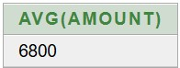

# Find the Sum of salaries of company

Select SUM(amount) from company;

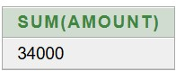

# Find the Maximum amount of company

Select Max(amount) from company;

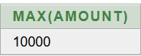

# Find the Minimum amount of company

Select Min(amount) from company;

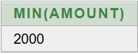

# Find the number of rows in a company

Select Count(*) from company;

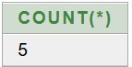

**Find the sum of amount of each company.**

select companyn,sum(amount) from company group by companyn;

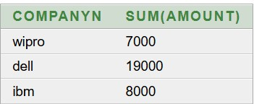

**Find the minimum amount of each company.**

select companyn,min(amount) from company group by companyn;

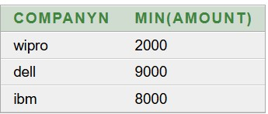

**Find the maximum amount of each company.**

select companyn,max(amount) from company group by companyn;

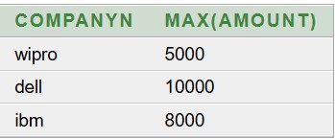

# Find the count of all the rows grouped by each company name. select companyn,count(*) from company group by companyn;

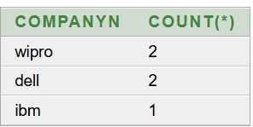

# Find the count of all the rows grouped by each company name & having count greater than 1. select companyn,count(*) from company group by companyn having count(*)>1;

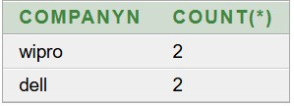

**Find the sum of amount of each company and having sum of amount greater than 10000.** select companyn,sum(amount) from company group by companyn having sum(amount)>10000;

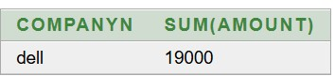

**AIM: 3.1 Perform Join Operations-Natural Join, Equi-Join, Outer Join, Left Outer Join, Right Outer Join, Inner Join and assess the impact of query plans on the performance of join heavy queries.**

**Description:**

JOIN Keyword is used in SQL queries for joining two or more tables.

# Types of Joins Inner Join

The INNER JOIN keyword selects records that have matching values in both tables. Syntax: select * from tablename1 inner join tablename2 on condition

# Outer Join

Outer Join is based on both matched and unmatched data.

It is divided into

1. Left outer join

The left outer join returns a resultset table with the matched data from the two tables and then the remaining rows of the left table and null from the right table's columns.

Syntax:

SELECT column-name-list FROM

table-name1 LEFT OUTER JOIN table-name2

ON table-name1.column-name = table-name2.column-name;

1. Right outer join

The right outer join returns a resultset table with the matched data from the two tables being joined, then the remaining rows of the right table and null for the remaining left table's columns. Syntax:

SELECT column-name-list FROM

table-name1 RIGHT OUTER JOIN table-name2

ON table-name1.column-name = table-name2.column-name;

# Natural join

It is based on column having same name and same datatype present in both the tables to be joined.

Syntax:

SELECT * FROM table-name1 NATURAL JOIN table-name2;

# Cross join

It will return a table which consists of records which combines each row from the first table -with each row of the second table.

Syntax:

select * from tablename1,tablename2

**Self Join**

A **self join** is a **join** in which a table is joined with itself.

# EQUI Join

An Equi Join in SQL is a type of join that combines rows from two or more tables based on a common column or set of columns, using only the equality operator (=) to compare the values in those columns.

Syntax

SELECT column-name-list FROM table1, table2....

WHERE table1.column_name =table2.column_name;

**Source Tables** select *from tb1;

|  |  |  |
| --- | --- | --- |
| **RNO** | **NAME** | **MARKS** |
| 503 | Suma | 40 |
| 504 | Raju | 70 |
| 505 | Ramu | 45 |
| 501 | Abhi | 50 |
| 502 | Ravi | 60 |

select * from tb2;

|  |  |
| --- | --- |
| **RNO** | **FEE** |
| 501 | 15000 |
| 502 | 5000 |
| 503 | 10000 |
| 504 | 25000 |

# Inner Join

select *from tb1 inner join tb2 on tb1.rno=tb2.rno; Or use the below query also select *from tb1 join tb2 on tb1.rno=tb2.rno;

|  |  |  |  |  |
| --- | --- | --- | --- | --- |
| **RNO** | **NAME** | **MARKS** | **RNO** | **FEE** |
| 503 | Suma | 40 | 503 | 10000 |
| 504 | Raju | 70 | 504 | 25000 |
| 501 | Abhi | 50 | 501 | 15000 |
| 502 | Ravi | 60 | 502 | 5000 |

# Left Outer Join

select * from tb1 left outer join tb2 on tb1.rno=tb2.rno;

|  |  |  |  |  |
| --- | --- | --- | --- | --- |
| **RNO** | **NAME** | **MARKS** | **RNO** | **FEE** |
| 501 | Abhi | 50 | 501 | 15000 |
| 502 | Ravi | 60 | 502 | 5000 |
| 503 | Suma | 40 | 503 | 10000 |
| 504 | Raju | 70 | 504 | 25000 |
| 505 | Ramu | 45 | - | - |

# Right outer join

select * from tb1 right outer join tb2 on tb1.rno=tb2.rno;

|  |  |  |  |  |
| --- | --- | --- | --- | --- |
| **RNO** | **NAME** | **MARKS** | **RNO** | **FEE** |
| 503 | Suma | 40 | 503 | 10000 |
| 504 | Raju | 70 | 504 | 25000 |
| 501 | Abhi | 50 | 501 | 15000 |
| 502 | Ravi | 60 | 502 | 5000 |

**Natural join** select *from tb1 natural join tb2;

|  |  |  |  |
| --- | --- | --- | --- |
| **RNO** | **NAME** | **MARKS** | **FEE** |
| 503 | Suma | 40 | 10000 |
| 504 | Raju | 70 | 25000 |
| 501 | Abhi | 50 | 15000 |
| 502 | Ravi | 60 | 5000 |

**Cross join** select *from tb1 cross join tb2; or use the below query

select * from tb1,tb2;

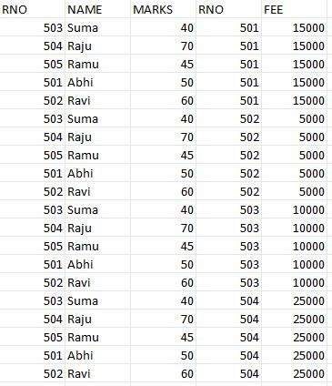

**Self Join:** select t1.rno, t2.name from tb1 t1,tb1 t2 where t1.rno=t2.rno;

|  |  |
| --- | --- |
| **RNO** | **NAME** |
| 503 | Suma |
| 504 | Raju |
| 505 | Ramu |
| 501 | Abhi |
| 502 | Ravi |

**EQUI Join:**

select * from tb1,tb2 where tb1.rno=tb2.rno;

|  |  |  |  |  |
| --- | --- | --- | --- | --- |
| **RNO** | **NAME** | **MARKS** | **RNO** | **FEE** |
| 503 | Suma | 40 | 503 | 10000 |
| 504 | Raju | 70 | 504 | 25000 |
| 501 | Abhi | 50 | 501 | 15000 |
| 502 | Ravi | 60 | 502 | 5000 |

**AIM: 3.2 Perform Set Operations-Union, Intersection, Set Difference Description:**  Set Operators

1. UNION is used to combine the results of two or more SELECT statements. It will -eliminate duplicate rows from its resultset.

Syntax:-

SELECT column_name FROM table1

UNION

SELECT column_name FROM table2;

1. UNION ALL This is similar to Union. But it also shows the duplicate rows.

Syntax:-

SELECT column_name FROM table1 UNION ALL

SELECT column_name FROM table2;

1. Intersect operation is used to combine two SELECT statements, but it only retuns the records which are common from both SELECT statements.

Syntax:-

SELECT column_name FROM table1 INTERSECT

SELECT column_name FROM table2;

1. The Minus operation combines results of two SELECT statements and return only those in the final result, which belongs to the first set of the result.

Syntax:-

SELECT column_name FROM table1 MINUS

SELECT column_name FROM table2;

# Source Tables Sailors Table

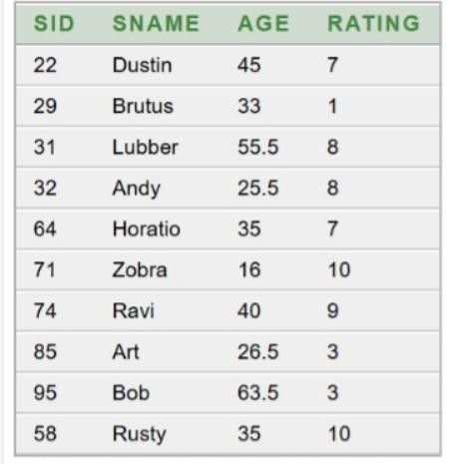

# Boats Table

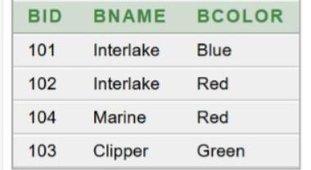

# Reserves Table

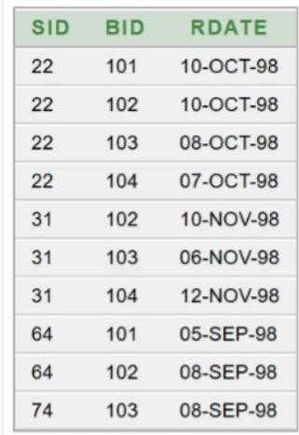

**Find the names of sailors who have reserved a red or a green boat** select s.sname from sailors s, reserves r,boats b where s.sid=r.sid and b.bid=r.bid and b.bcolor='Red'

UNION

select s1.sname from sailors s1,reserves r1,boats b1 where s1.sid=r1.sid and r1.bid=b1.bid and b1.bcolor='Green';

|  |
| --- |
| **SNAME** |
| Dustin |
| Horatio |
| Lubber |
| Ravi |

**Find the names of sailors who have reserved a red or a green boat** select s.sname from sailors s, reserves r,boats b where s.sid=r.sid and b.bid=r.bid and b.bcolor='Red' UNION all

select s1.sname from sailors s1,reserves r1,boats b1 where s1.sid=r1.sid and r1.bid=b1.bid and b1.bcolor='Green';

|  |
| --- |
| **SNAME** |
| Dustin |
| Lubber |
| Horatio |
| Dustin |
| Lubber |
| Dustin |
| Lubber |
| Ravi |

**Find the names of sailors who have reserved both a red and green boat.**

select s.sname from sailors s, reserves r,boats bwhere s.sid=r.sid and b.bid=r.bid and b.bcolor='Red'

INTERSECT

|  |
| --- |
| **SNAME** |
| Dustin |
| Lubber |

select s1.sname from sailors s1,reserves r1,boats b1where s1.sid=r1.sid and r1.bid=b1.bid and b1.bcolor='Green';

**Find the names of sailors who have reserved a red boat but not a green boat** select s.sname from sailors s, reserves r,boats b where s.sid=r.sid and b.bid=r.bid and b.bcolor='Red'

MINUS

select s1.sname from sailors s1,reserves r1,boats b1 where s1.sid=r1.sid and r1.bid=b1.bid and b1.bcolor='Green';

|  |
| --- |
| **SNAME** |
| Horatio |

**AIM:3.3 Implementation of Correlated sub-queries and Nested queries Description:**

# Nested Queries

A query within another SQL query and embedded within the WHERE clause.In Nested Query, Inner query runs first, and only once. Outer query is executed with result from Inner query. 1) IN and NOT IN

It tests whether a value is in a given set of elements

Syntax:-

Select column_names from table_name

Where column_name IN/NOT IN (Select column_name from table_name

Where condition);

2) ALL and ANY

It is used to compare a value to a list. It is preceded by comparison operator and followed by a list.

Syntax:-

Select column_name from table_name

Where column_name comparison operator ALL/ANY(subquery);

**Correlated Sub query**

In Correlated sub query***,***a query is nested inside another queryand an inner query uses values from the outer query

Syntax:-

SELECT *column_names* FROM *table_name*

WHERE EXISTS/NOT EXISTS

(SELECT *column_name* FROM *table_name* WHERE *condition*);

**Find the names of sailors who have reserved boat no 103.** select s.sname from sailors s where s.sid IN( select r.sid from reserves r where r.bid=103);

|  |
| --- |
| **SNAME** |
| Dustin |
| Lubber |
| Ravi |

**Find the names of sailors who have not reserved boat no 103.** select s.sname from sailors s where s.sid NOT IN( select r.sid from reserves r

where r.bid=103);

|  |
| --- |
| **SNAME** |
| Brutus |
| Andy |
| Horatio |
| Zobra |
| Art |
| Bob |
| Rusty |

**Find the sailor id with the highest rating** select s.sid from sailors s where s.rating>=all(select s1.rating from sailors s1);

|  |
| --- |
| **SID** |
| 71 |
| 58 |

**Find the sailor id whose rating is better than some sailor called andy** select s.sid from sailors s where s.rating>ANY(select s1.rating from sailors s1 where s1.sname='Andy');

|  |
| --- |
| **SID** |
| 71 |
| 58 |
| 74 |

**Correlated Sub query**

**Find the names of sailors who have reserved boat no 103**  select s.sname from sailors s where EXISTS(select * from reserves r where s.sid=r.sid and r.bid=103);

|  |
| --- |
| **SNAME** |
| Dustin |
| Lubber |
| Ravi |

# Find the names of sailors who have not reserved boat no 103

select s.sname from sailors s where NOT EXISTS(select * from reserves r where s.sid=r.sid and r.bid=103);

|  |
| --- |
| **SNAME** |
| Brutus |
| Andy |
| Horatio |
| Zobra |
| Art |
| Bob |
| Rusty |

**AIM: 3.4 Creating and Querying views and Materialized views. Description: View**

A view is a logical table based on the result set of an SQL Statement. A view contains rows and columns, just like a table. The fields in a view are fields from one or more base tables in the database. We can apply all DDL and DML statements on views.

**Syntax:**

Create or replace force/noforce view viewname as

Select column_list from table_list

Where condition with read only|check option  **Dropping a view syntax:** Drop view viewname;

# Source Table

|  |  |  |
| --- | --- | --- |
| **ROLLNO** | **NAME** | **MARKS** |
| 501 | jyothi | 90 |
| 502 | sai | 95 |
| 504 | yamuna | 70 |
| 505 | padma | 60 |
| 503 | ravi | 80 |

**Creating View** create view myview as select rollno,name from st1; view created

# Display Views and Tables in your login select * from tab;

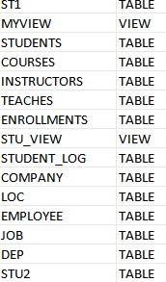

**Inserting a row in view**  insert into myview values(506,'prathisha');

1 row(s) inserted **Display view** select * from myview;

|  |  |
| --- | --- |
| **ROLLNO** | **NAME** |
| 501 | jyothi |
| 502 | sai |
| 506 | prathisha |
| 504 | yamuna |
| 505 | padma |
| 503 | ravi |

**Displaying Table** select * from st1;

|  |  |  |
| --- | --- | --- |
| **ROLLNO** | **NAME** | **MARKS** |
| 501 | jyothi | 90 |
| 502 | sai | 95 |
| 506 | prathisha | - |
| 504 | yamuna | 70 |
| 505 | padma | 60 |
| 503 | ravi | 80 |

**Deleting a row in a view** delete from myview where rollno=506;

1 row(s) deleted

**Display view** select * from myview;

|  |  |
| --- | --- |
| **ROLLNO** | **NAME** |
| 501 | jyothi |
| 502 | sai |
| 504 | yamuna |
| 505 | padma |
| 503 | ravi |

**Displaying Table** select * from st1;

|  |  |  |
| --- | --- | --- |
| **ROLLNO** | **NAME** | **MARKS** |
| 501 | jyothi | 90 |
| 502 | sai | 95 |
| 504 | yamuna | 70 |
| 505 | padma | 60 |
| 503 | ravi | 80 |

**Change the Structure of the View** create or replace view myview as select * from st1; view created.

# Creating View when base table doesn’t exist

create or replace force view abc as select * from dummy_table; Warning: View created with compilation errors.  **Creating Read only view** create view myview1 as select * from st1 with read only; view created

**Inserting Data in Read only view**  insert into myview1 values(503,'prathisha',80); ORA-01733: virtual column not allowed here update myview1 set name='suma' where rollno=505;

ORA-01733: virtual column not allowed here **Displaying view select * from myview1;**

|  |  |  |
| --- | --- | --- |
| **ROLLNO** | **NAME** | **MARKS** |
| 501 | jyothi | 90 |
| 502 | sai | 95 |
| 504 | yamuna | 70 |
| 505 | padma | 60 |
| 503 | ravi | 80 |

**Creating View with check option**  create view myview2 as select * from st1 where marks<101 with check option; view created.

**Inserting a row into view**  insert into myview2 values(504,'siri',101);

**ORA-01402: view WITH CHECK OPTION where-clause violation**

# Dropping view

Drop View myview1;

View dropped

**220**